DESIGN ASSIGNMENT

For this design assignment, we are focusing on the activity of viewing an ad on craigslist.com. We will be using two different metaphors to help users understand this activity. The first metaphor is reading the classifieds section in a newspaper and the second metaphor is visiting a flea market to buy an item.

METAPHOR ONE -> Going through the classifieds section on a newspaper

Low-fidelity prototype
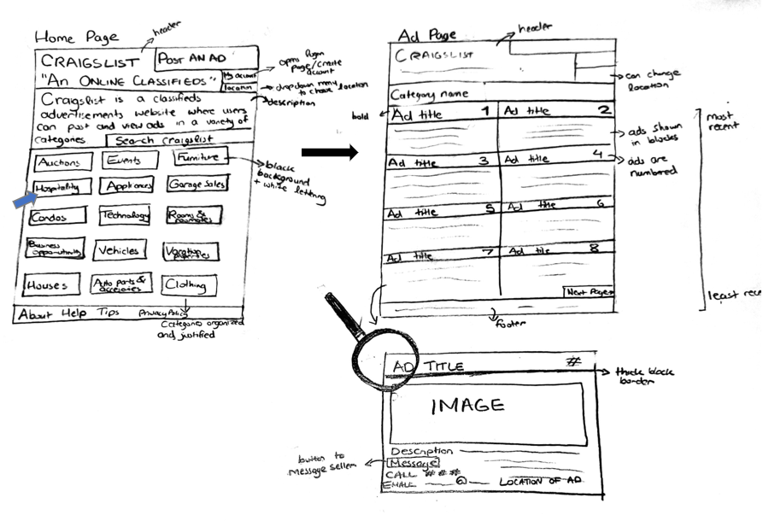

Scenario

Mr. and Mrs. Johnson are quite excited for their grand-daughter Alexis to be turning 18 and want to gift a car to her for her birthday in order to help her cut time for her daily commute to the university by avoiding public transit. While they want to find the perfect vehicle for their grand-daughter, Mr. and Mrs. Johnson also want to be able to afford the price of the car in full and would like a budget-friendly as well as fuel-efficient car for Alexis. Mr. Johnson had heard about Craigslist from his neighbor who had recently used the website to buy his passion project Corvette and decided to take a look at it for himself. When arriving on Craigslist, Mr. Johnson spent some time looking around to find the automobile section where certain budget vehicles were listed. He wanted to find a car which would suit the budget of under $10,000 and under 150,000 kilometers and found the listing to be minimized to only a few options. The search required him to scan through the system multiple times before he could understand that there’s no possibility of being able to search for a vehicle according to a specific make and model or even according to the range of years such as only searching for cars that range between the years 2009 and 2018. Additionally, he was unable to find information about the various accidents history as there was no such feature for a Carfax to be shown. Eventually, Mr. Johnson may turn to another source for finding the right vehicle where he may have to put in less effort for the search.

Analysis

The above low-fidelity prototype depicts craigslist.com using the metaphor of reading a classifieds section in a newspaper. The two interaction types that best describe the users activity of viewing an ad is instructing and manipulating. In the craigslist interface, users instruct the system that they want to look at an ad. Users have to select from a set of categories using a mouse, then the users are required to scroll through a list of ads. Then users instruct the system that they want to contact the seller by pressing “reply”. Craigslist.com requires users to issue instructions to a system by selecting options from menus, pressing buttons and typing in commands. The newspaper metaphor further takes into account the manipulating interaction type as it capitalizes on user’s knowledge of how they manipulate objects in the physical world. The metaphor depicts the user viewing a newspaper, flipping through to the classifieds section, looking at the categories, selecting the required category, then viewing the ads underneath.Then, it gives users different ways to contact the poster.

The positives of the low-fidelity prototype are:
- There is a clear description of the purpose of craigslist.com
- There is a large and clear button to post an ad which corresponds with Fitt’s law that claims that larger targets are easier to hit than smaller ones
- The categories are clear to read
- Displays common categories that users would be aware of and are prevalent in the classified section of a newspaper
- Grid based structure with header, footer, columns and rows
- In the ad page, the ads are displayed in columns, are numbered, have bolded titles, and are organized by date/time of posting with the most recent being on top
  - This is the same structure used in newspapers where the ads have a clear title, an image, a concise description and ways to contact the seller
- Ability to change location using the location button
- Overall, the design is organized, follows the structure of a classifieds page in a newspaper, and ads are easy to view

The negatives of the low-fidelity prototype are:
- Categories are not organized in a specific manner
- User is only able to see one image of the ad
- Name of the poster is not visible
- Design looks overcrowded
- A lack of colour
- Ads lack a viewer count
- Ads are small and crowded
- Placement of “My account” button and “Location” button is awkward
- Search bar is in a bad location

Iteration of low-fidelity prototype and scenarios

Below is the finished low-fidelity prototype. These are some of the changes that have been made to get to the finished prototype:
- Categories have been organized in “Most viewed”, “Suggested” and “Recent ad searches”
- “Post an Ad” button, “Location” button, “My account” button and “Search” button have been organized in a navigation bar
- The description of the website has been made more inviting
- Ads have larger margins to decrease crowdedness
- Less ads are placed in one page to allow for a larger ad size and more space between ads
- Arrows added on to the sides of the main image so users can view other images
- The ad description includes a section for name of poster
- Added a viewer count to each ad
- More color has been added to make the interface more visually appealing

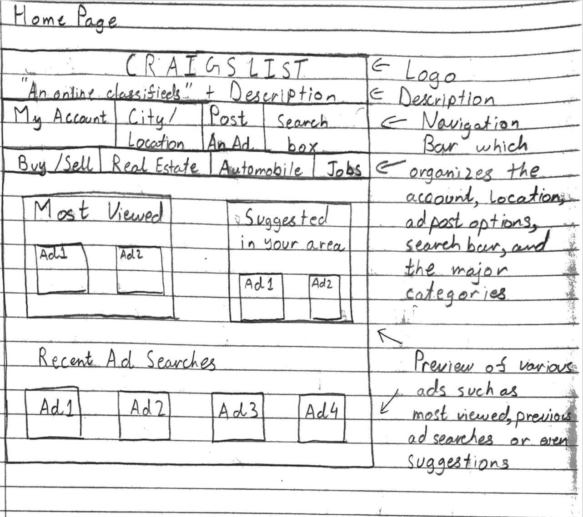
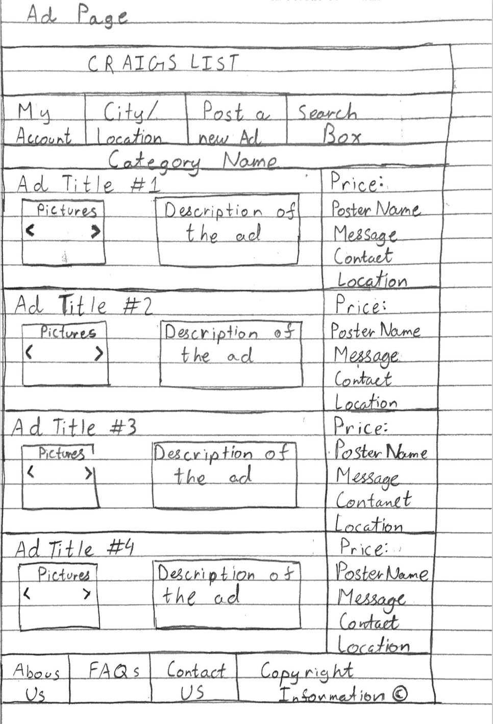

METAPHOR TWO -> Going to a flea market

Low-fidelity prototype

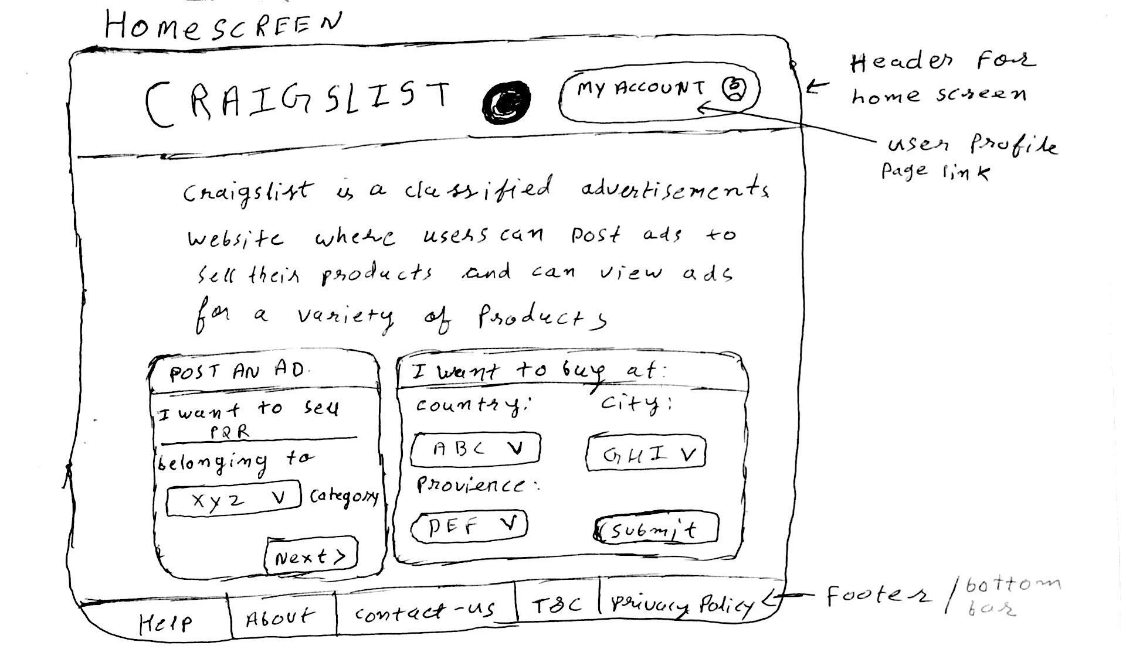
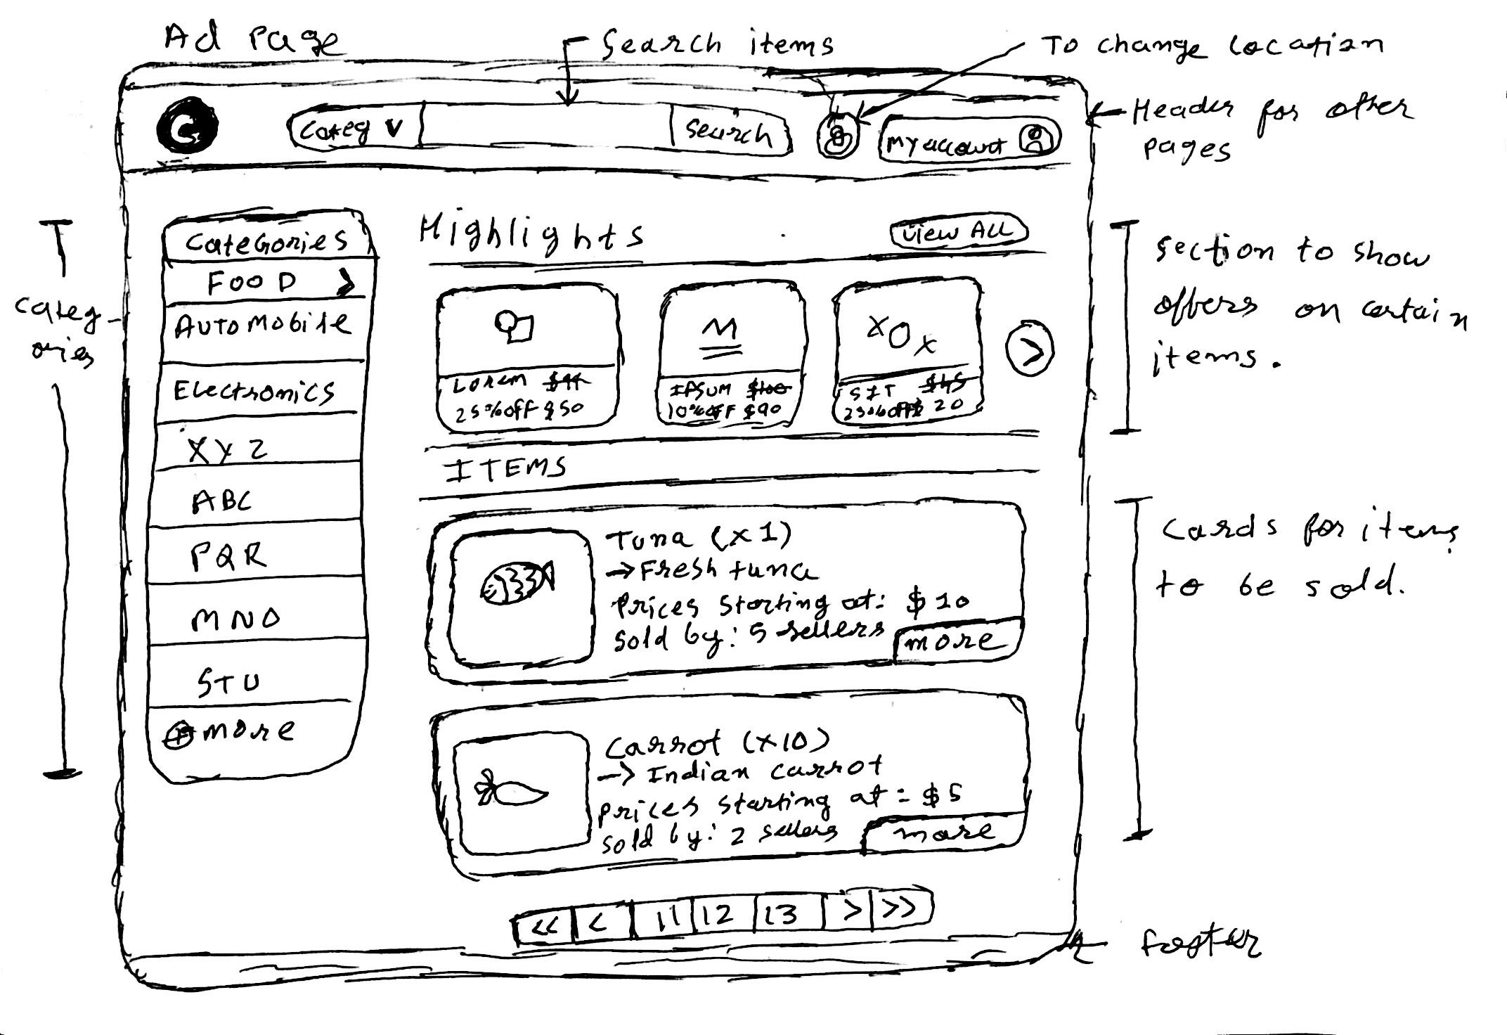
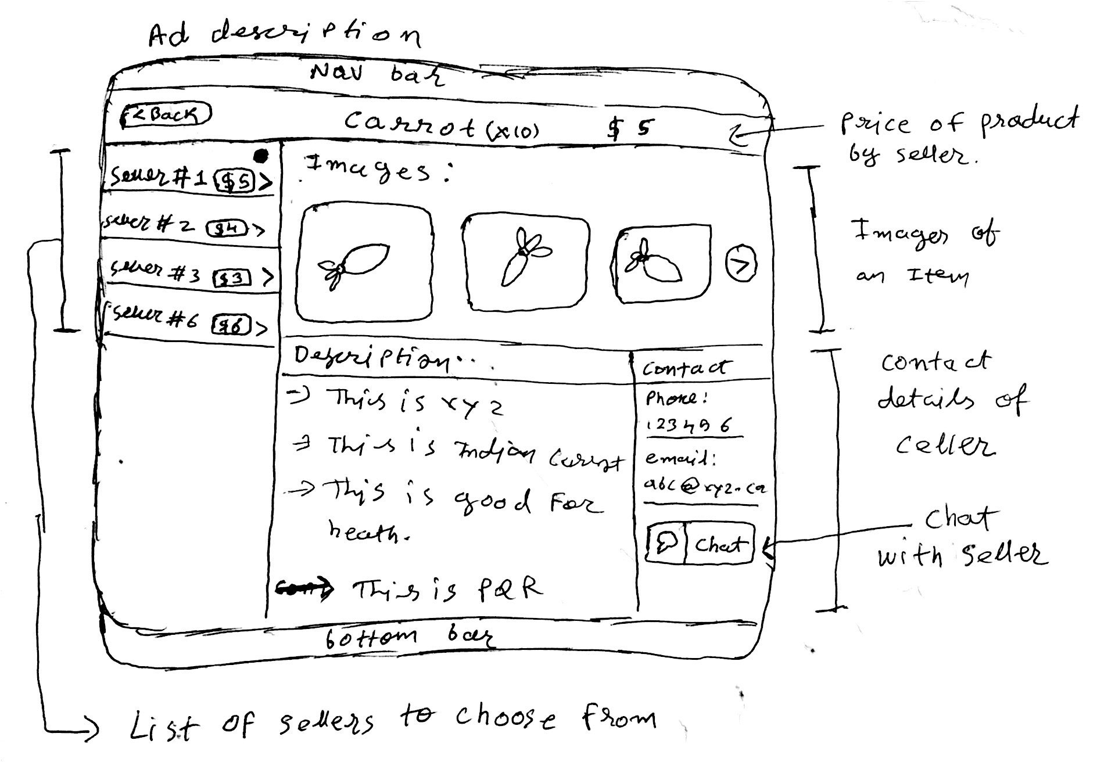

Scenario

John is a 32 year old man who likes to shop for most of his things through online websites. He needs to relocate a lot of times due to his nature of work, hence he visits the craigslist website to sell his existing household items as he can’t move them to a new location if the location is far from his old house. Sometimes he overestimates his products on sale and reduces its price but still, he couldn’t sell it as he thinks the customer should get a notification as he reduces the price. He buys a lot of things from online websites. He searches for that specific product and he clicks on that product to check its description but he never gets good detail of product or he hardly gets product images to see its physical appearance. Then he buys a product and some days after he found that there are so many sellers who are selling the same product with a lower price. John gets angry with himself and he questions why this seller’s product didn't pop up when he searched for it. John put’s a stack of some specific items as he needs to relocate and he wants them available every time but he always wishes that if he’s buying a product in such a large quantity then why doesn't he get any discount? Why can’t he chat with the seller to discuss prices? He also notices that everytime he contacts a seller he is exposing his contact details to him.

Analysis

Craigslist.com is a website which facilitates its users to buy and sell items following a consumer-to-consumer business model. Here the task to buy an item is taken into consideration.

In order to look for an item and purchase it, the user has to perform the following activities:
- Choose a geographical region (city, country).
- Choose the category.
- Look at existing items, search for items or apply filters to get the intended results.
- Read the description and get the contact details of the seller by clicking the "reply" button.

The low-fidelity prototype shown above incarnates craigslist.com using the metaphor of visiting a flea market to purchase an item. It is designed taking into consideration the user's shopping experience in a flea market. The considered facts are as follows:

- The user wants to visit different flea markets and starts with one located at a specific location belonging to a specific category(i.e a food market or a clothes market).
- Upon entrance to the market, he sees the sellers advertising regarding various offers upfront.
- If the item he needs has an offer then, he first visits the store which is providing an offer.
- If he doesn't find any offer for the intended item then, he will look for the seller who is selling at the lowest price first and check the item at the seller's store.
- If the first seller does not have the satisfactory item then, he moves to another seller.
- Once, he finds the item in the satisfactory condition he bargains for the price and proceeds to purchase the item.

Positive of low fidelity prototype:

- We have a clear, minimalistic, and responsive design.
- The user can chat with the seller.
- The user can zoom a product image and see in 360-degree view.
- Customer will get notification of products whose price has been reduced by the seller.
- The same Item sold by different sellers is also taken into consideration.
- Based on the user’s mental model to look for low price stuff first, the lowest price for an item is displayed first.
- User’s privacy concerns are also taken into considerations adding a chat feature. As everyone does not want to expose their personal contact details to an unknown person.

Negative of low fidelity prototype:

- The user will not have the option to post ad other than the homepage.
- Introduction to filters in the prototype can be difficult.
- The user experience of a responsive version of this prototype may not be as good as the desktop one.
- The user needs to go back to select a category from the product page.

Iteration of low-fidelity prototype and scenarios
Home Page(before) :

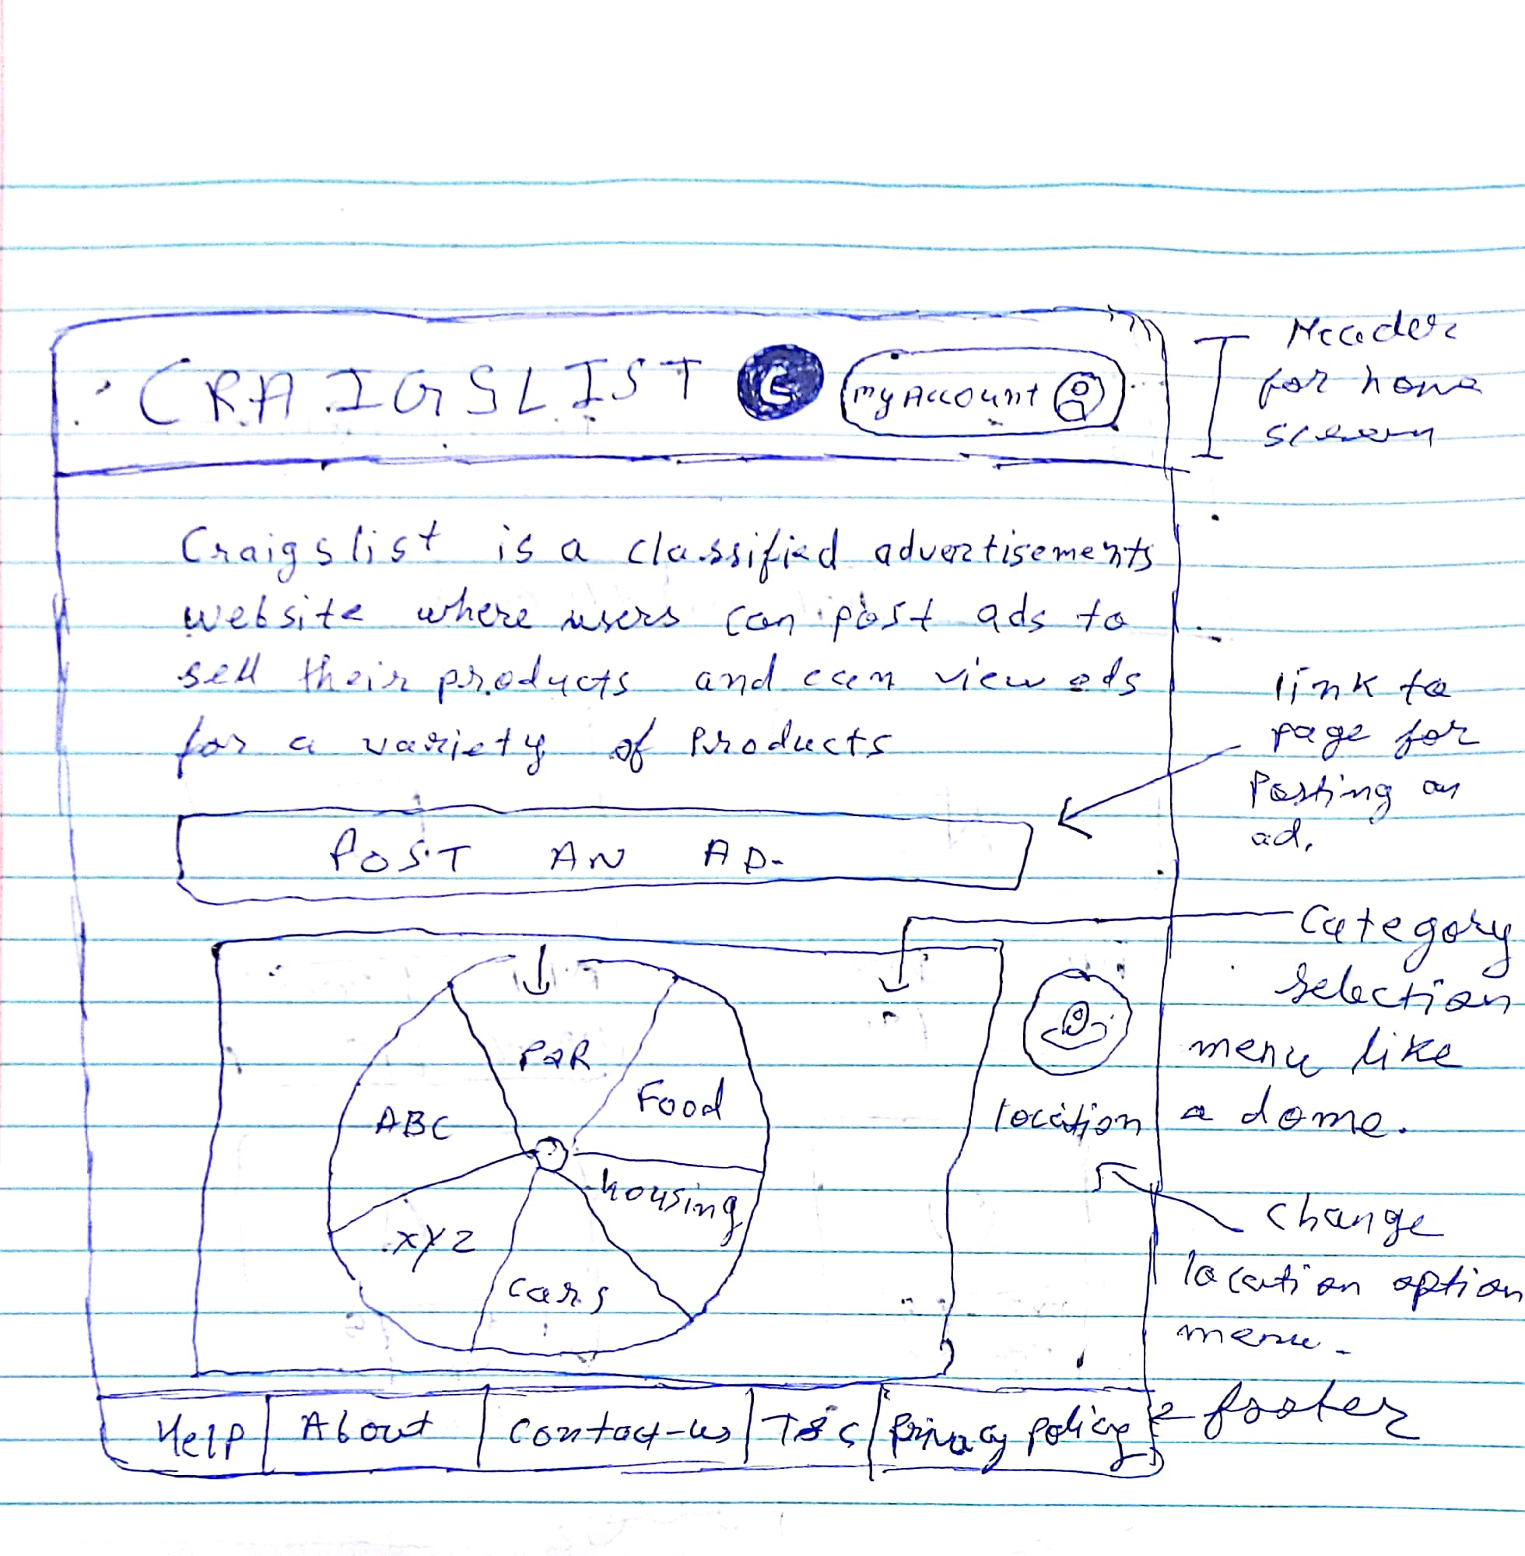

Home Page(After):

- We have first thought about the real design of flea market on the homepage but it was destroying user experience in responsive mode hence we changed the design.
- We changed the initial design to post an ad. So that the user can better idea.
- We added a form to choose the location instead of taking a user to another page.
- We shifted the category section to next page as you have to first select the location and then category.

Advertisement Page(Before):
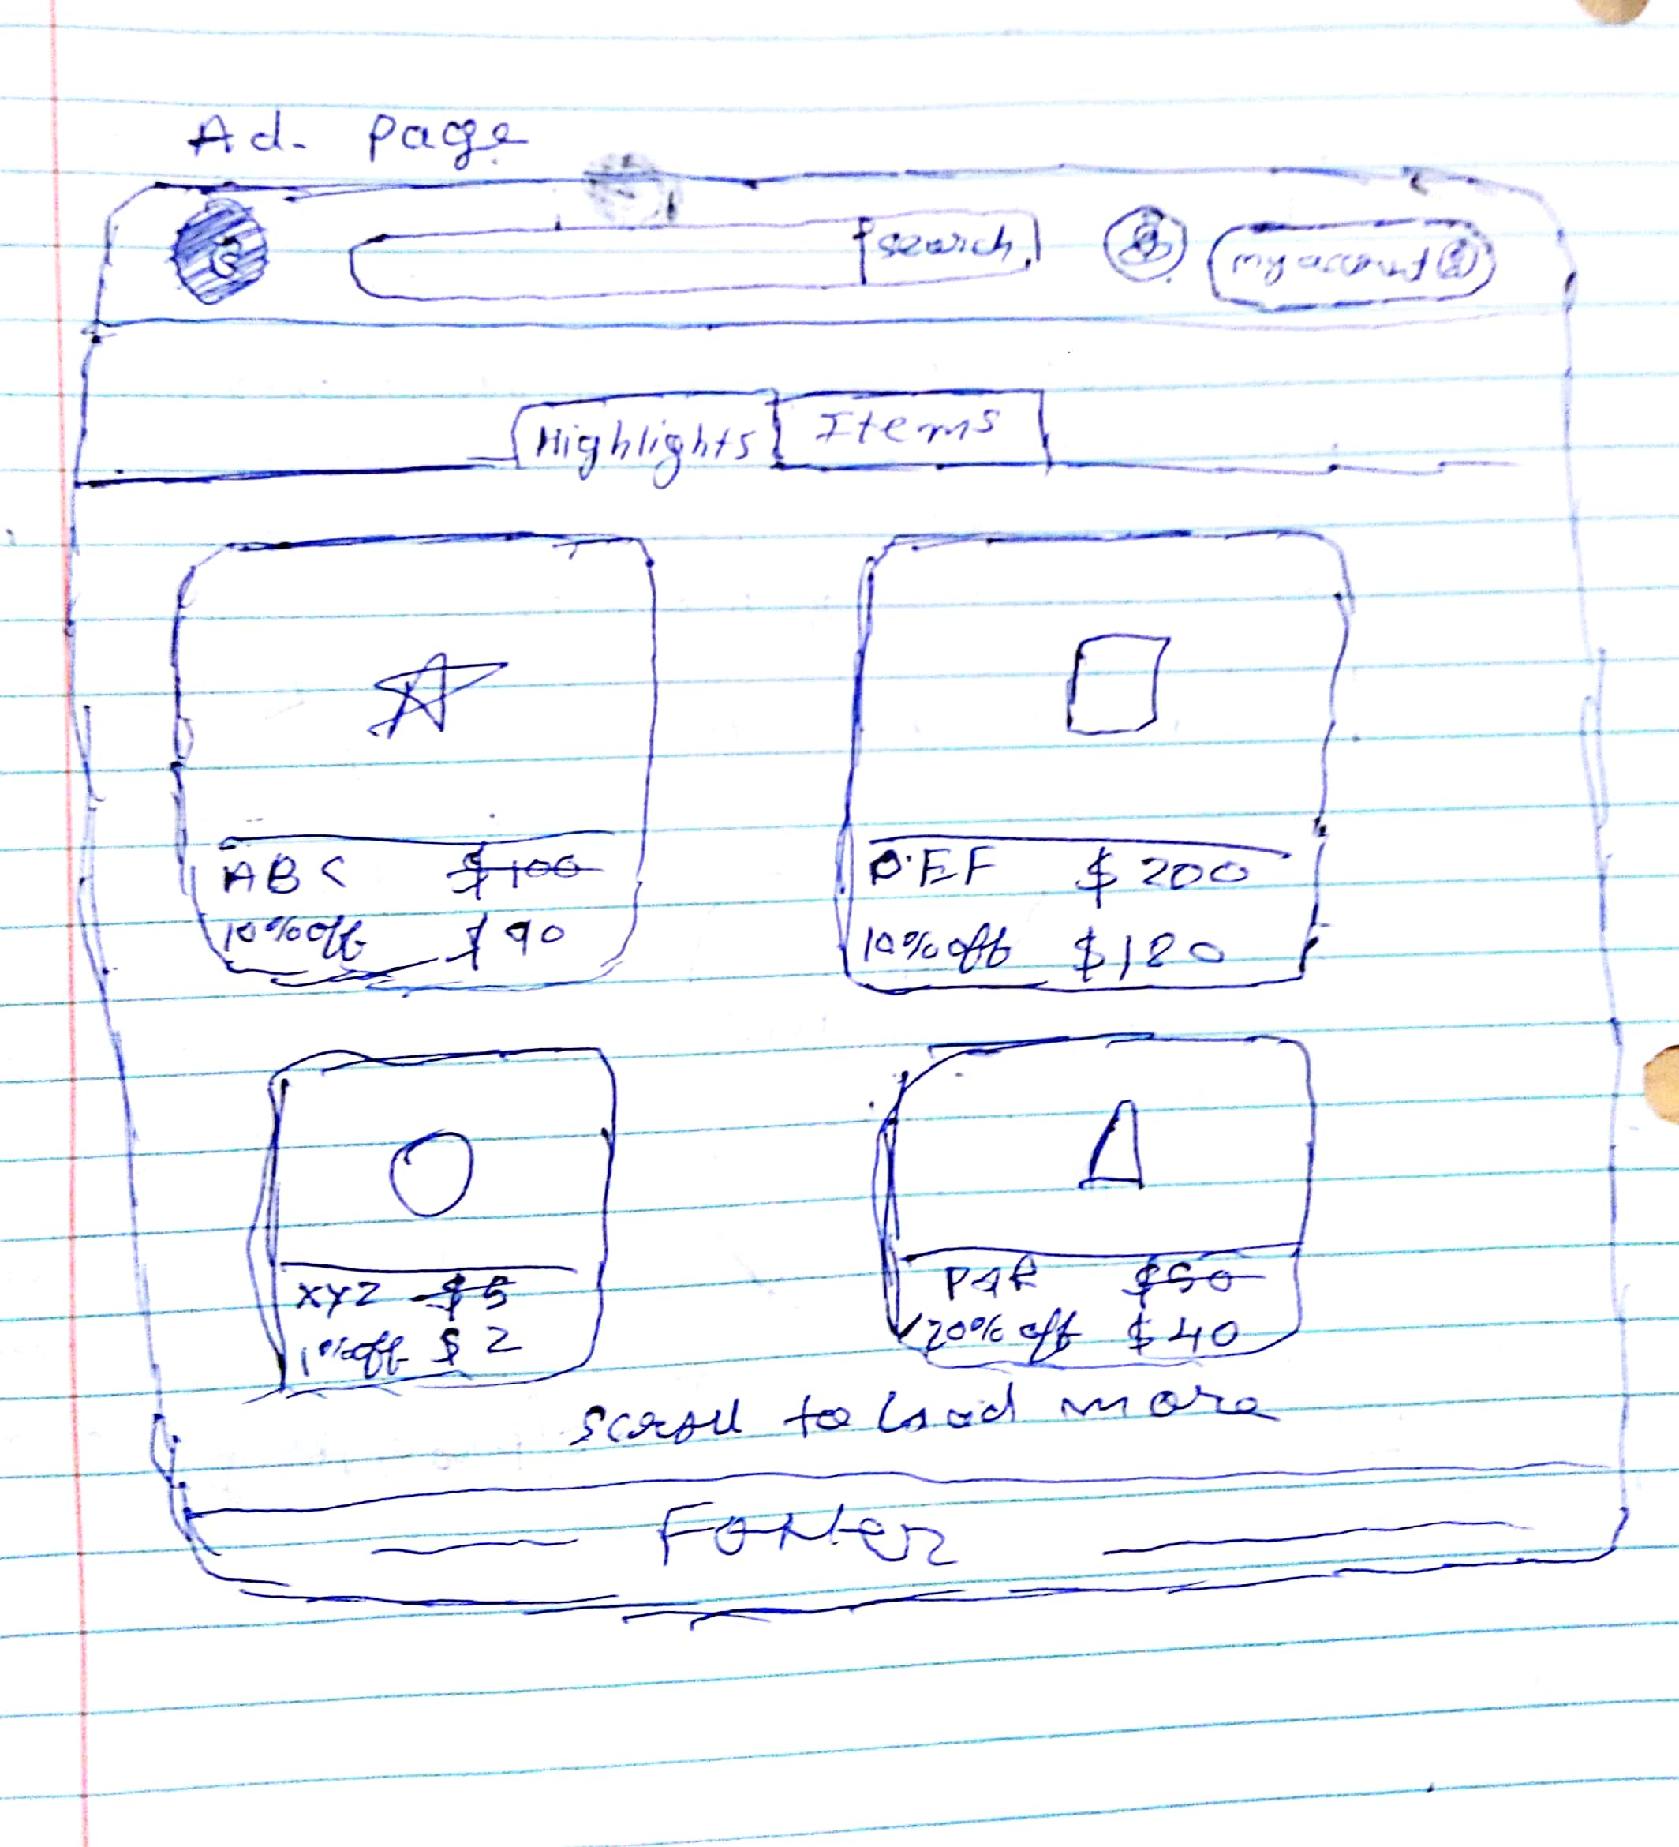

Advertisement Page(After):
- Category to the search component was added to enhance the search experience.
- We introduced highlight feature when we thought the user should get a notification as a product’s price is reduced by the seller.
- We made tabs for “highlights” and “items” sections earlier but we replaced them with what is there in the current design. Keeping tabbed views will in a way force the user to navigate between different views and due to this sometimes a user might not visit the “highlights” tab at all.
- We added the category menu as a sidebar on left so that user can easily switch between categories. It tries to mimic the user’s behaviour in real world of knowing where the different markets are and how to reach at different places easily.
- We removed “load more items on scroll” instead we added pagination.

Advertisement/Item Description Page(Before):

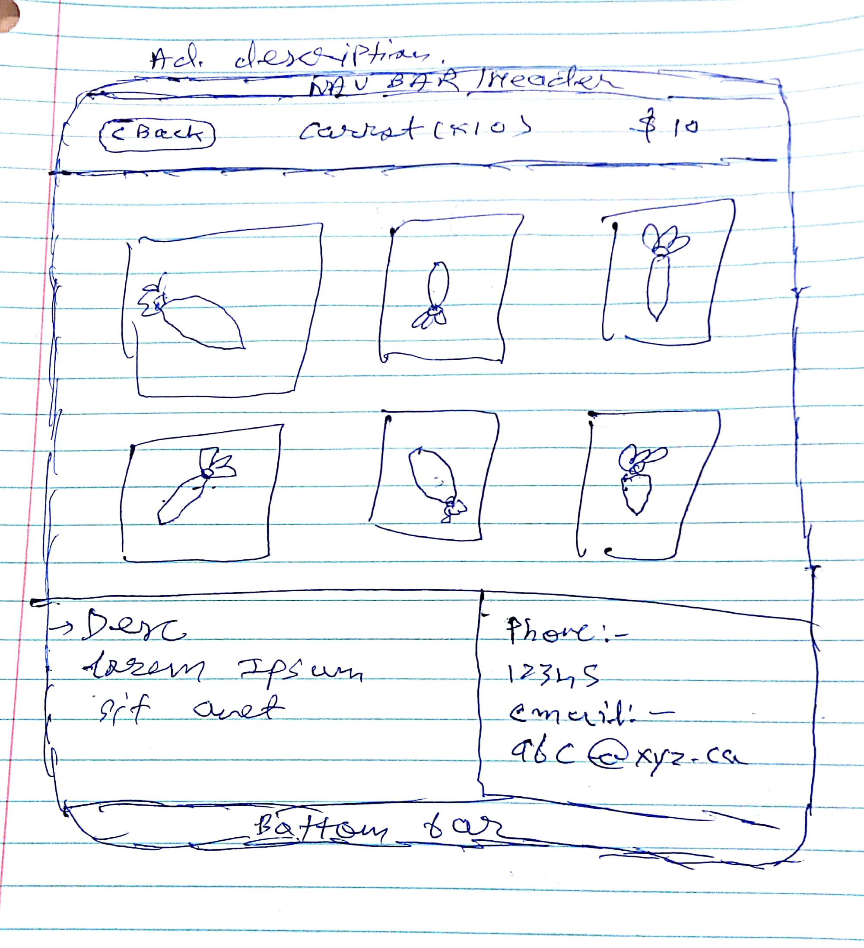

Advertisement/Item Description Page(After):

- We have introduced a chat feature when we thought not to disclose user contact details.
- We showed a product with different sellers and its price as, in a flea market a person can find same product sold by different sellers.
- Price at which a particular seller is selling an item was added to the item/Ad. Description screen. This was done to enable the experience of being in a flea market and looking at the prices at which different sellers are selling the same item.
- Earlier we decided to display the item’s images in a grid fashion but later we replaced it with a slider to support the feature of lazy loading keeping the user experience rich.

